**BANK LOAN REPORT QUERY DOCUMENT**

**A. SUMMARY**

**KPI’s**

**1. Total Loan Applications**

SELECT COUNT(ID) AS TOTAL_LOAN-APPLICATONS FROM BANK_LOAN;

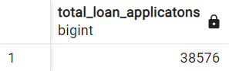

**2. MTD Loan Applications**

SELECT COUNT(ID) AS MTD_TOTAL_LOAN_APPLICATONS FROM BANK_LOAN

WHERE EXTRACT(MONTH FROM ISSUE_DATE) = 12 AND EXTRACT(YEAR FROM ISSUE_DATE) = 2021;

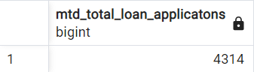

**3. PMTD Loan Applications**

SELECT COUNT(ID) AS PMTD_TOTAL_LOAN_APPLICATONS FROM BANK_LOAN

WHERE EXTRACT(MONTH FROM ISSUE_DATE) = 11 AND EXTRACT(YEAR FROM ISSUE_DATE) = 2021;

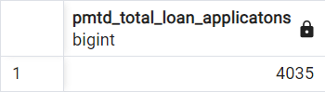

**4. Total Funded Amount**

SELECT SUM(LOAN_AMOUNT) AS TOTAL_FUNDED_AMOUNT FROM BANK_LOAN;

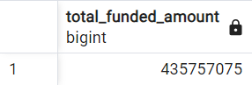

**5. MTD Total Funded Amount**

SELECT SUM(LOAN_AMOUNT) AS MTD_TOTAL_FUNDED_AMOUNT FROM BANK_LOAN

WHERE EXTRACT(MONTH FROM ISSUE_DATE) = 12 AND EXTRACT(YEAR FROM ISSUE_DATE) = 2021;

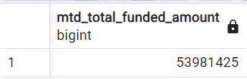

**6. PMTD Total Funded Amount**

SELECT SUM(LOAN_AMOUNT) AS PMTD_TOTAL_FUNDED_AMOUNT FROM BANK_LOAN

WHERE EXTRACT(MONTH FROM ISSUE_DATE) = 11 AND EXTRACT(YEAR FROM ISSUE_DATE) = 2021;

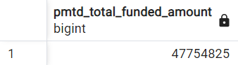

**7. Total Amount Received**

SELECT SUM(TOTAL_PAYMENT) AS TOTAL_AMOUNT_RECEIVED FROM BANK_LOAN;

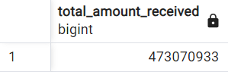

**8. MTD Total Amount Received**

SELECT SUM(TOTAL_PAYMENT) AS MTD_TOTAL_AMOUNT_RECEIVED FROM BANK_LOAN

WHERE EXTRACT(MONTH FROM ISSUE_DATE) = 12 AND EXTRACT(YEAR FROM ISSUE_DATE) = 2021;

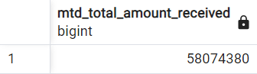

**9. PMTD Total Amount Received**

SELECT SUM(TOTAL_PAYMENT) AS PMTD_TOTAL_AMOUNT_RECEIVED FROM BANK_LOAN

WHERE EXTRACT(MONTH FROM ISSUE_DATE) = 11 AND EXTRACT(YEAR FROM ISSUE_DATE) = 2021;

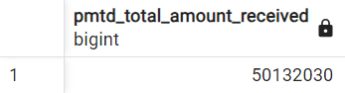

**10. Average Interest Rate**

SELECT ROUND(AVG(CAST(INT_RATE AS NUMERIC)), 4) * 100 AS AVERAGE_INTEREST_RATE FROM BANK_LOAN;

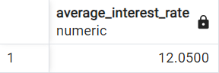

**11. MTD Average Interest Rate**

SELECT ROUND(AVG(CAST(INT_RATE AS NUMERIC)), 4) * 100 AS MTD_AVERAGE_INTEREST_RATE FROM BANK_LOAN

WHERE EXTRACT(MONTH FROM ISSUE_DATE) = 12 AND EXTRACT(YEAR FROM ISSUE_DATE) = 2021;

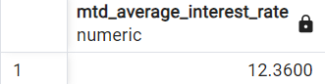

**12. PMTD Average Interest Rate**

SELECT ROUND(AVG(CAST(INT_RATE AS NUMERIC)), 4) * 100 AS PMTD_AVERAGE_INTEREST_RATE FROM BANK_LOAN

WHERE EXTRACT(MONTH FROM ISSUE_DATE) = 11 AND EXTRACT(YEAR FROM ISSUE_DATE) = 2021;

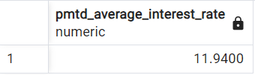

**13. Average DTI**

SELECT ROUND(AVG(CAST(DTI AS NUMERIC)), 4) * 100 AS AVERAGE_DTI FROM BANK_LOAN

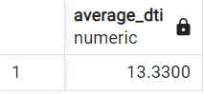

**14. MTD Average DTI**

SELECT ROUND(AVG(CAST(DTI AS NUMERIC)), 4) * 100 AS MTD_AVERAGE_DTI FROM BANK_LOAN

WHERE EXTRACT(MONTH FROM ISSUE_DATE) = 12 AND EXTRACT(YEAR FROM ISSUE_DATE) = 2021;

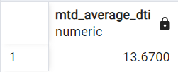

**15. PMTD Average DTI**

SELECT ROUND(AVG(CAST(DTI AS NUMERIC)), 4) * 100 AS PMTD_AVERAGE_DTI FROM BANK_LOAN

WHERE EXTRACT(MONTH FROM ISSUE_DATE) = 11 AND EXTRACT(YEAR FROM ISSUE_DATE) = 2021;

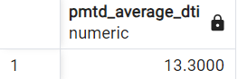

**GOOD LOAN ISSUED**

**1. Good Loan Percentage**

SELECT

(COUNT(CASE WHEN LOAN_STATUS='Fully Paid' OR LOAN_STATUS='Current' THEN id END) * 100)

/

COUNT(id) AS GOOD_LOAN_PERCENTAGE

FROM BANK_LOAN;

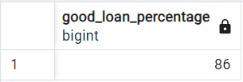

**2. Good Loan Applications**

SELECT COUNT(ID) AS GOOD_LOAN_APPLICATIONS FROM BANK_LOAN

WHERE LOAN_STATUS='Fully Paid' OR LOAN_STATUS='Current'

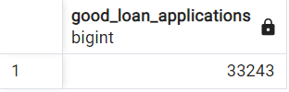

**3. Good Loan Funded Amount**

SELECT SUM(LOAN_AMOUNT) AS GOOD_LOAN_FUNDED_AMOUNT FROM BANK_LOAN

WHERE LOAN_STATUS='Fully Paid' OR LOAN_STATUS='Current'

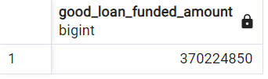

**4. Good Loan Received Amount**

SELECT SUM(TOTAL_PAYMENT) AS GOOD_LOAN_RECIEVED_AMOUNT FROM BANK_LOAN

WHERE LOAN_STATUS='Fully Paid' OR LOAN_STATUS='Current'

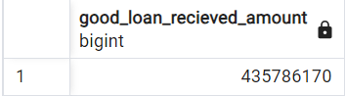

**BAD LOAN ISSUED**

**1. Bad Loan Percentage**

SELECT

(COUNT(CASE WHEN LOAN_STATUS='Charged Off' THEN id END) * 100)

/

COUNT(id) AS BAD_LOAN_PERCENTAGE

FROM BANK_LOAN;

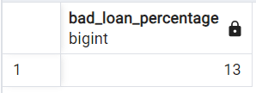

**2. Bad Loan Applications**

SELECT COUNT(ID) AS BAD_LOAN_APPLICATIONS FROM BANK_LOAN

WHERE LOAN_STATUS='Charged Off'

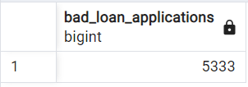

**3. Bad Loan Funded Amount**

SELECT SUM(LOAN_AMOUNT) AS BAD_LOAN_FUNDED_AMOUNT FROM BANK_LOAN

WHERE LOAN_STATUS='Charged Off'

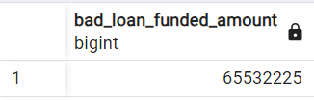

**4. Bad Loan Received Amount**

SELECT SUM(TOTAL_PAYMENT) AS BAD_LOAN_RECIEVED_AMOUNT FROM BANK_LOAN

WHERE LOAN_STATUS='Charged Off'

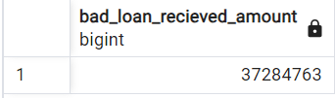

**LOAN STATUS**

SELECT

loan_status,

COUNT(id) AS TOTAL_Loan_APPLICATIONS,

SUM(total_payment) AS Total_Amount_Received,

SUM(loan_amount) AS Total_Funded_Amount,

AVG(int_rate* 100) AS Interest_Rate,

AVG(dti*100) AS DTI

FROM

bank_loan

GROUP BY

loan_status

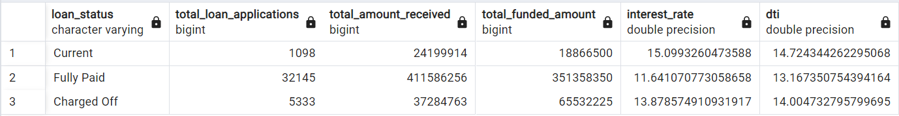

SELECT

loan_status,

SUM(total_payment) AS MTD_Total_Amount_Received,

SUM(loan_amount) AS MTD_Total_Funded_Amount

FROM

bank_loan

WHERE

EXTRACT(MONTH FROM issue_date) = 12

GROUP BY

loan_status

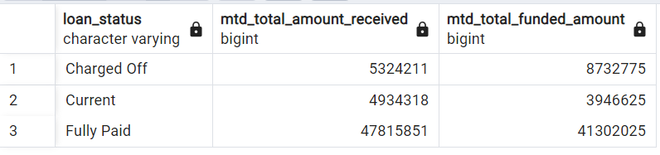

**B. OVERVIEW**

**1. MONTH**

SELECT

EXTRACT(MONTH FROM ISSUE_DATE) AS MONTH_NUMBER,

TO_CHAR(ISSUE_DATE, 'Month') AS MONTH_NAME,

COUNT(ID) AS TOTAL_LOAN_APPLICATIONS,

SUM(LOAN_AMOUNT) AS TOTAL_FUNDED_AMOUNT,

SUM(TOTAL_PAYMENT) AS TOTAL_RECEIVED_AMOUNT

FROM

BANK_LOAN

GROUP BY EXTRACT(MONTH FROM ISSUE_DATE), TO_CHAR(ISSUE_DATE, 'Month')

ORDER BY EXTRACT(MONTH FROM ISSUE_DATE)

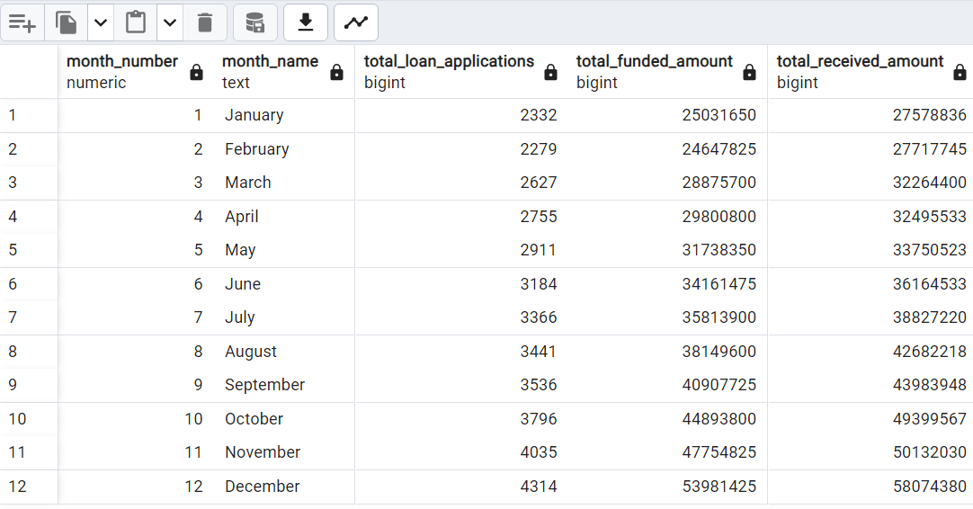

**2. STATE**

SELECT

address_state AS State,

COUNT(id) AS Total_Loan_Applications,

SUM(loan_amount) AS Total_Funded_Amount,

SUM(total_payment) AS Total_Amount_Received

FROM bank_loan

GROUP BY address_state

ORDER BY address_state

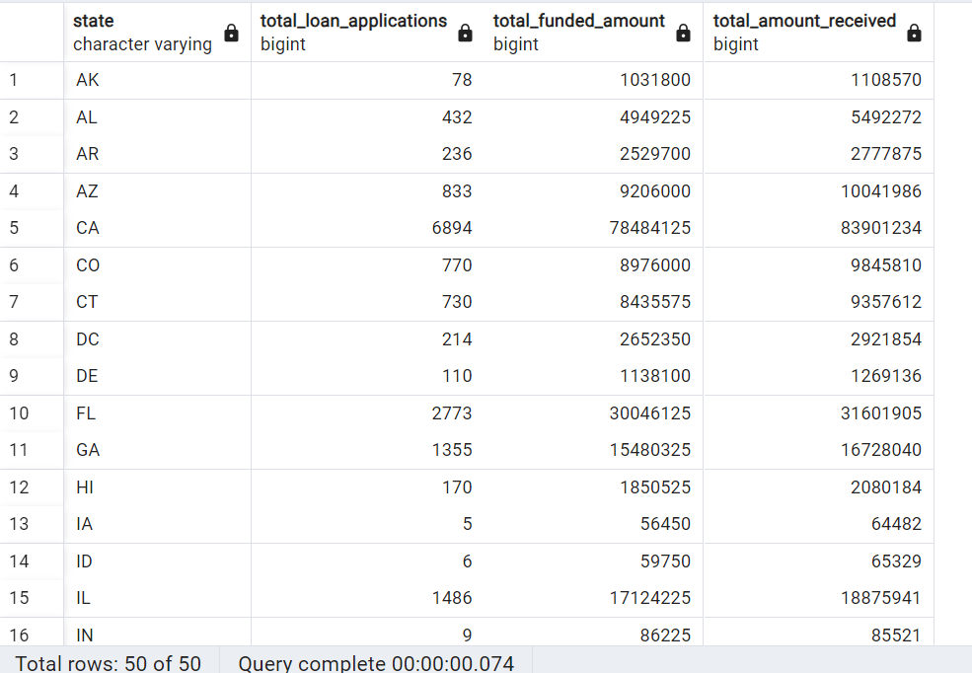

**3. TERM**

SELECT

term AS Term,

COUNT(id) AS Total_Loan_Applications,

SUM(loan_amount) AS Total_Funded_Amount,

SUM(total_payment) AS Total_Amount_Received

FROM bank_loan

GROUP BY term

ORDER BY term

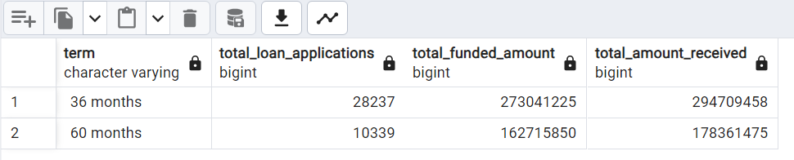

**4. EMPLOYEE LENGTH**

SELECT

emp_length AS Employee_Length,

COUNT(id) AS Total_Loan_Applications,

SUM(loan_amount) AS Total_Funded_Amount,

SUM(total_payment) AS Total_Amount_Received

FROM bank_loan

GROUP BY emp_length

ORDER BY emp_length

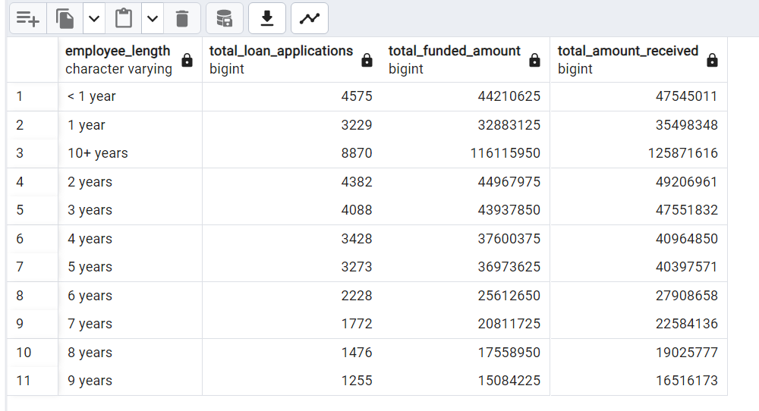

**5. PURPOSE**

SELECT

purpose AS PURPOSE,

COUNT(id) AS Total_Loan_Applications,

SUM(loan_amount) AS Total_Funded_Amount,

SUM(total_payment) AS Total_Amount_Received

FROM bank_loan

GROUP BY purpose

ORDER BY purpose

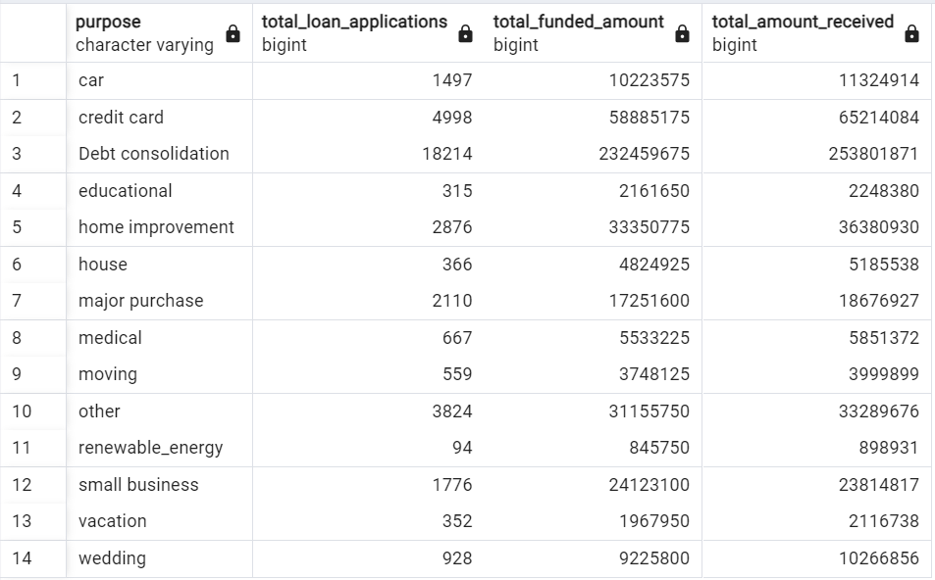

**6. HOME OWNERSHIP**

SELECT

home_ownership AS Home_Ownership,

COUNT(id) AS Total_Loan_Applications,

SUM(loan_amount) AS Total_Funded_Amount,

SUM(total_payment) AS Total_Amount_Received

FROM bank_loan

GROUP BY home_ownership

ORDER BY home_ownership

